WEEK 2:

**Exercise 1: Mocking and Stubbing Scenario:**

Pom.xml

<project xmlns="http://maven.apache.org/POM/4.0.0" xmlns:xsi="http://www.w3.org/2001/XMLSchema-instance" xsi:schemaLocation="http://maven.apache.org/POM/4.0.0 https://maven.apache.org/xsd/maven-4.0.0.xsd">

<modelVersion>4.0.0</modelVersion>

<groupId>com.example</groupId>

<artifactId>MockitoExample</artifactId>

<version>0.0.1-SNAPSHOT</version>

<dependencies>

<!-- JUnit 5 -->

<dependency>

<groupId>org.junit.jupiter</groupId>

<artifactId>junit-jupiter-api</artifactId>

<version>5.10.0</version>

<scope>test</scope>

</dependency>

<dependency>

<groupId>org.junit.jupiter</groupId>

<artifactId>junit-jupiter-engine</artifactId>

<version>5.10.0</version>

<scope>test</scope>

</dependency>

<!-- Mockito -->

<dependency>

<groupId>org.mockito</groupId>

<artifactId>mockito-core</artifactId>

<version>5.12.0</version>

<scope>test</scope>

</dependency>

</dependencies>

</project>

ExternalApi.java

package com.example;

public interface ExternalApi {

String getData();

}

MyService.java

package com.example;

public class MyService {

private final ExternalApi externalApi;

public MyService(ExternalApi externalApi) {

this.externalApi = externalApi;

}

public String fetchData() {

return externalApi.getData();

}

}

MyServiceTest.java

package com.example;

import org.junit.jupiter.api.Test;

import org.mockito.Mockito;

import static org.mockito.Mockito.*;

import static org.junit.jupiter.api.Assertions.*;

public class MyServiceTest {

*@Test*

public void testExternalApi() {

// Step 1: Create mock object

ExternalApi mockApi = Mockito.*mock*(ExternalApi.class);

// Step 2: Stub method

*when*(mockApi.getData()).thenReturn("Mock Data");

// Step 3: Use mock in service

MyService service = new MyService(mockApi);

String result = service.fetchData();

// Step 4: Assert

*assertEquals*("Mock Data", result);

}

}

Output:

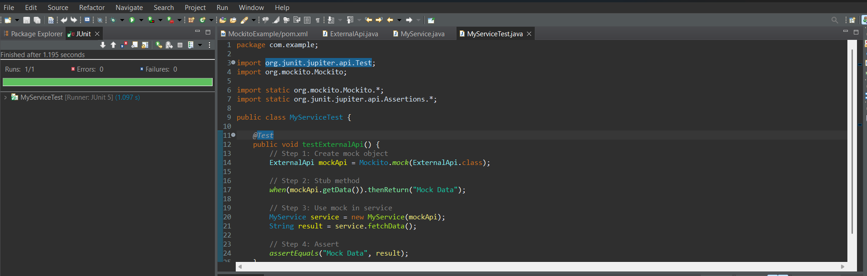

**Exercise 2: Verifying Interactions**

Pom.xml

<project xmlns="http://maven.apache.org/POM/4.0.0" xmlns:xsi="http://www.w3.org/2001/XMLSchema-instance" xsi:schemaLocation="http://maven.apache.org/POM/4.0.0 https://maven.apache.org/xsd/maven-4.0.0.xsd">

<modelVersion>4.0.0</modelVersion>

<groupId>com.example</groupId>

<artifactId>MockitoVerifyExample</artifactId>

<version>0.0.1-SNAPSHOT</version>

<dependencies>

<!-- JUnit 5 -->

<dependency>

<groupId>org.junit.jupiter</groupId>

<artifactId>junit-jupiter-api</artifactId>

<version>5.10.0</version>

<scope>test</scope>

</dependency>

<dependency>

<groupId>org.junit.jupiter</groupId>

<artifactId>junit-jupiter-engine</artifactId>

<version>5.10.0</version>

<scope>test</scope>

</dependency>

<!-- Mockito -->

<dependency>

<groupId>org.mockito</groupId>

<artifactId>mockito-core</artifactId>

<version>5.12.0</version>

<scope>test</scope>

</dependency>

</dependencies>

</project>

ExternalApi.java

package com.example;

public interface ExternalApi {

String getData();

}

MyService.java

package com.example;

public class MyService {

private final ExternalApi externalApi;

public MyService(ExternalApi externalApi) {

this.externalApi = externalApi;

}

public String fetchData() {

return externalApi.getData();

}

}

MyServiceTest.java

package com.example;

import org.junit.jupiter.api.Test;

import org.mockito.Mockito;

import static org.mockito.Mockito.*;

public class MyServiceTest {

*@Test*

public void testVerifyInteraction() {

// Step 1: Create mock object

ExternalApi mockApi = Mockito.*mock*(ExternalApi.class);

// Step 2: Use the mock in the service

MyService service = new MyService(mockApi);

service.fetchData(); // Should call mockApi.getData()

// Step 3: Verify interaction

*verify*(mockApi).getData();

}

}

Output:

